grep command: grep command search for a particular string from file

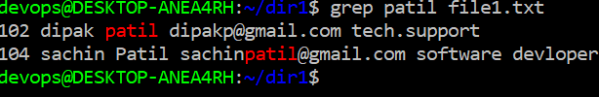

Case1:

To ignore the upper and lower case while searching

grep –i keyword filename

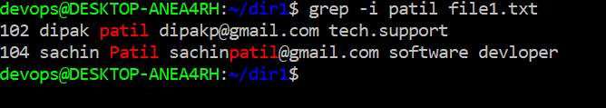

Case 2 :

To search except given keyword from file

Grep –v keyword filename

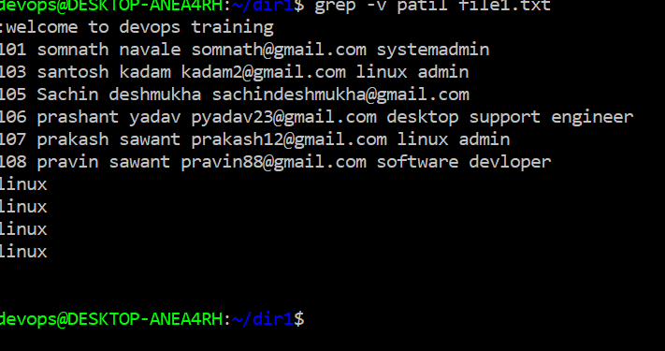

Case3:

To print how many times given keyword present in file

Grep –c keyword filename

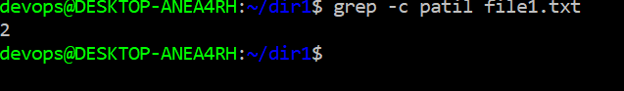

Case 4:

To search exact match of given keyword in file.

Grep –w keyword filename

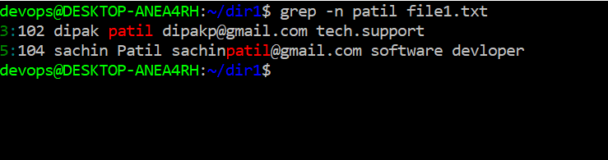

Case 5:

To print the line no. of matches of given a file

Grep –n keyword filename

